# Cloning and Pushing Github Pages Repository with Github Desktop:

Contents

Cloning and Pushing Github Pages Repository with Github Desktop: 1

Learning Objective: 1

Submission 2

*How to know if you are successful:* 2

Assignment Rubric: 2

## Learning Objective:

Upon completion of this task, students will be able to use Github Desktop to clone a Github Pages repository, add their website files to the local repository folder, commit their changes, push their changes to Github, and successfully publish their website at the designated Github Pages URL.

Step 1: Go to www.github.com and log in or sign up for an account. If you are signing up, you will need to provide an email address, username, and password. Once you are logged in, you will be taken to your Github dashboard.

Step 2: Click on the "+" icon in the top right corner of the screen and select "New repository." This will take you to the "Create a new repository" page.

Step 3: Give your repository a name that matches your Github username. For example, if your Github username is "johndoe," then name your repository "johndoe.github.io."

* Check the box to “Add a README file”
* Click the Create Repository button at the bottom of the page

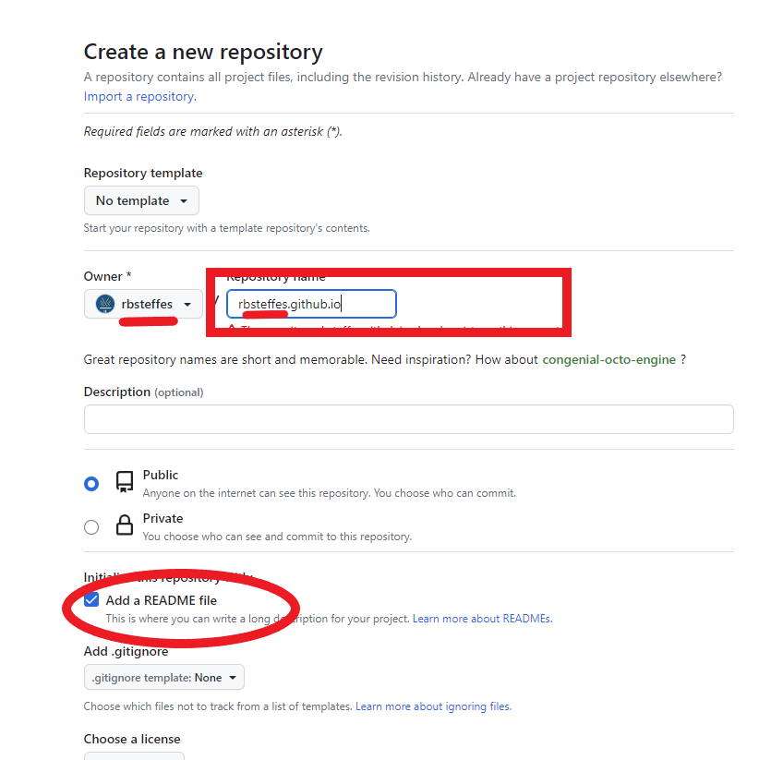

Step 4: Download Github Desktop from desktop.github.com and install it on your computer. Once the installation is complete, open the program.

Step 5: Log in to Github Desktop using your Github account. If you are not already logged in, you will be prompted to do so when you open the program.

Step 6: Click on the "+" icon in the top left corner of the screen and select "Clone a repository." This will open a window that shows a list of your Github repositories.

Step 7: Choose the repository you want to clone from the list of your Github repositories. In this case, select the repository with the name "username.github.io."

Step 8: Choose the location on your computer where you want to clone the repository. You can either choose an existing folder or create a new one.

Step 9: Click on "Clone repository." This will download a copy of the repository to your computer.

Step 10: You will add files to this folder in future assignments, so be sure you can find it. Find the README file in your folder, and edit as described below.

Step 11: Open Github Desktop and select the repository you just cloned in the left column.

Step 12: Commit your changes by writing a summary of the changes you made in the "Summary" field and clicking on the "Commit" button in the bottom left corner of the screen.

Step 13: Push your changes to Github by clicking on the "Push origin" button in the top right corner of the screen.

Step 14: Take a screenshot of your repository on GitHub, and the cloned folder on your hard drive.

## Submission:

Once you have completed the assignment, edit the README.md file in your repository with the following information:

1. Your name and email address
2. A brief description of your Github account
3. A brief description of the repository you created
4. A brief description of the steps you took to clone the repository onto your local machine

Then, push your changes to Github and submit the repository URL to your instructor with your screenshots

## How to know if you are successful:

You were able to clone your Github Pages repository, edit your README file, commit your changes, push your changes to Github

### Assignment Rubric:

| **Criteria** | **Excellent (90-100)** | **Good (80-89)** | **Fair (70-79)** | **Needs Improvement (60-69)** | **Poor (Below 60)** |
| --- | --- | --- | --- | --- | --- |
| Creating a Github Account | Successfully created a Github account with all required information and verified email address. | Created a Github account with minor errors, but verified email address. | Created a Github account with some missing information or did not verify email address. | Created a Github account with significant errors or did not verify email address. | Did not create a Github account. |
| Creating a Repository | Successfully created a repository with a clear and descriptive name, description, and chose the appropriate visibility. | Created a repository with a mostly clear and descriptive name, description, and chose the appropriate visibility. | Created a repository with a somewhat clear and descriptive name, description, and visibility may be inappropriate. | Created a repository with an unclear or inappropriate name, description, or visibility. | Did not create a repository. |
| Cloning a Repository | Successfully cloned the repository onto the local machine using the correct commands and navigated to the appropriate directory. | Successfully cloned the repository, but with minor errors in commands or navigation. | Cloned the repository with significant errors in commands or navigation. | Cloned the repository but encountered major errors in commands or navigation. | Did not clone the repository. |
| README.md | Created a well-structured and informative README.md file that includes all required information. | Created a README.md file that is mostly informative but may be lacking in structure or detail. | Created a README.md file with some missing or unclear information. | Created a README.md file with significant missing or unclear information. | Did not create a README.md file. |
| Submission | Submitted the repository URL on time and met all submission requirements. | Submitted the repository URL with minor errors or missed some submission requirements. | Submitted the repository URL with significant errors or missed several submission requirements. | Submitted the repository URL with major errors or missed most submission requirements. | Did not submit the repository URL. |

Grading Points:

1. Creating a Github Account (20 points)
2. Creating a Repository (20 points)
3. Cloning a Repository (20 points)
4. README.md (20 points)
5. Submission (20 points)

Each criterion will be graded on a scale of 0-20, with a total possible score of 100 points. The grading scale is as follows:

90-100 points = Excellent 80-89 points = Good 70-79 points = Fair 60-69 points = Needs Improvement Below 60 points = Poor